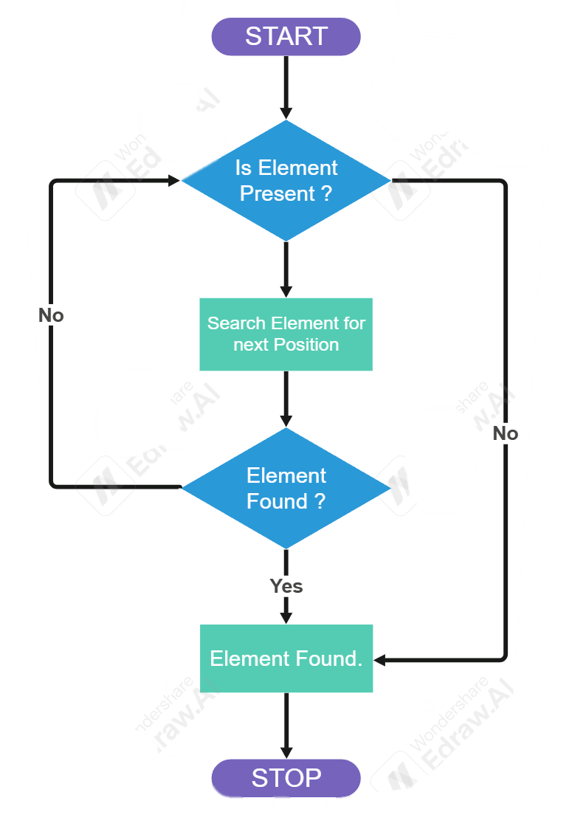**Applications of Linear Search Algorithm:**

**LINEAR SEARCH ALGORITHM TimeComp: O(n)**

* **Unsorted Lists:** When we have an unsorted array or list, linear search is most commonly used to find any element in the collection.
* **Small Data Sets:** Linear Search is preferred over binary search when we have small data sets with
* **Searching Linked Lists:** In linked list implementations, linear search is commonly used to find elements within the list. Each node is checked sequentially until the desired element is found.
* **Simple Implementation:** Linear Search is much easier to understand and implement as compared to Binary Search or Ternary Search.

**PSEUDO CODE :**

**1. Take input array from user.**

**2. Take element you want to search from user.**

**3. Start from 1st element in array to last.**

**4. IF match found:**

**then -> Print Message + index;**

**ELSE :**

**Move to next element in array;**

**5. END.**

**Advantages of Linear Search Algorithm:**

* Linear search can be used irrespective of whether the array is sorted or not. It can be used on arrays of any data type.
* Does not require any additional memory.
* It is a well-suited algorithm for small datasets.

**Disadvantages of Linear Search Algorithm:**

* Linear search has a time complexity of O(N), which in turn makes it slow for large datasets.
* Not suitable for large arrays.

**When to use Linear Search Algorithm?**

* When we are dealing with a small dataset.
* When you are searching for a dataset stored in contiguous memory.

**BINARY SEARCH ALGORITHM TimeComp: O(n)**